To do version 1:
Json component definition
Json component scaffolding
Json component (de)serialising

Template Inheritance
Two-list system of components
Templates

To do later:
Version migration scaffolding + parser constructor (two way?)
Json parser that returns bigint and bigfloat

Two-list system of components
An entity can have an entity in one and only one of either two lists, which form the two-list composit list. Herein, for each component type, there is a traditional list for itself per-entity. These are owned only by said entity, and can only be changed by said entity. We call this list Individual.
The second list has, per entity, stored a pointer to another pointer, which points to a shared component. This list we call Shared. This component cannot be altered by the systems itself. This double pointer system means that two entities can share a component, and have that component be changed during gameplay.
Redirection types <T> | Contains
Redirection<T> | pointer to Redirection<T>  or  pointer to T
In the Shared list we save a pointer to a "Redirection" object. A Redirection object can point to either another redirection object or to a value. This allows entities to share things in a flexible way. IE it is possible to have all "zombie" entities share a redirection object to the zombie texture, and change the zombie texture object, or swap it, by changing the redirection object itself.
It also allows you to handle inheritance, where a live entity can point to the redirection object of the template, where the template can have its redirection object point to the redirection object of another template. See illustration below.
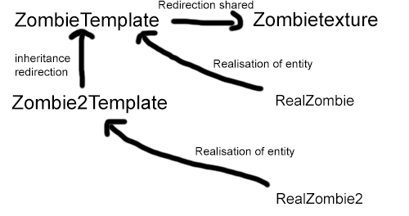

Json class scaffolding
Includes a DeepCopy command, which makes a full, deep copy of a component and its contents.

Version migration scaffolding + parser constructor (two way?)
Try to implement all migrations as programmatically as possible, this makes two way migration possible (nice feature to have). If you force a two way operation it will allow people to backwards port their worlds/entities/whatever if they wish to do so.

